**Shinkai Makoto Anime Style Image Transformation**

**-** Abulaiti Akeli

**Abstract**

In this paper, I am exploring AI techniques to transform arbitrary real-life images into Shinkai Makoto style anime images. I will discuss and compare some of the possible AI techniques to transfer the style of the image, including Neural Style Transfer (NST), and Generative Adversarial Network (GAN). For this project, I only implemented NST because of my limitation, which I will discuss more about it later in this paper. This paper also covers detail implementation, result and the problems of the NST. To get a better result and achieve my goal of using arbitrary real-life images as input, I also implemented image similarity search to retrieve similar style images from the dataset to match content images. In the end, I will compare my project with another similar project using GAN method and non-AI related method like Photoshop, wrap up with my final conclusion and thought.

**Introduction**

I believe many anime enjoyers like me have the wish of turning the real-life into anime. While this is only going to be a beautiful fantasy, it is possible to turn any real-life images that we have into anime style images. In this project, I will create a specific image transform application with AI incorporated to transfer any real-life images into anime style images. For this project, I chose Shinkai Makoto’s style. Shinkai Makoto is a very famous Japanese anime animator/director, he directed lots of famous anime such as “Your Name”, “Weathering with you”, “The Garden of Words”, etc. His anime art style is very unique and characteristic, while having typical anime aesthetic, it also has extremely realistic finish, which I think is perfect for the purpose of this project. The core of this entire project is image style transfer with AI techniques, more specifically, using machine learning, deep learning or Artificial Neural Network (ANN) to build a training model to learn the style of the specific images, and then apply that style to the other images.

**Neural Style Transfer**

Neural style transfer (NST) is an algorithm that use deep neural networks to transfer a digital image, or video’s appearance or visual style to another image or video. Leon Gatys and his colleagues first introduced NST in 2015 in the paper called “Image Style Transfer Using Convolutional Neural Network”, and it was accepted by the peer-reviewed CVPR conference in 2016. NST is based on histogram-based texture synthesis algorithms, and it incorporates convolutional neural network (CNN) features for the image analogies problem. Gatys used a pre-trained VGG-19 model to perform object recognition using the ImageNet dataset. I also use this VGG-19 model in my project, which will be explained in later part. The problem with this method is that it can only use a**single image** as the representation of the style, which isn’t quite what I want since applying a style from a single image may not work well with different type of image content scenarios. I will try to resolve this problem in my implementation. The good thing about this method is that it is less computational power hunger and easier to apply.

**Generative Adversarial Network**

A generative adversarial network (GAN) is a powerful class of neural networks frameworks which is used for unsupervised learning, designed by Ian Goodfellow and his colleagues in June 2014. GAN has two competing neural networks: a generative network and a discriminative network. The generator network tries to generate realistic samples to fool the discriminator, while the discriminator tries to distinguish real samples from fake samples. These two models work against each other to create the best undistinguishable result. When it comes to using for image style transfer, the biggest advantage of GAN over NST is that it can train multiple images with multiple styles at the same time, thus it is able to capture the artist’s style in its entirety, this is exactly what I need for my project. However, it takes a lot of time, data and computational power to train the generator and discriminator for the GAN. My computer simply can’t handle it, even Google Colab is not capable enough with a lot of time and usage restrictions. In the end, I decided to give up on this method although it could possibly provide me the best result. Fortunately, I found a similar anime style image transformation project using GAN on the Github, so I can at least see how it performs against NST for this project.

**Implementation with NST**

This is detail implementation of my final approach using NST, it was done using Google Colab, core packages and libraries I used in this implementation include tensorflow, os, cv2, matplotlib, numpy and functools.

First, I import following images as the content image(left) and style image(right):

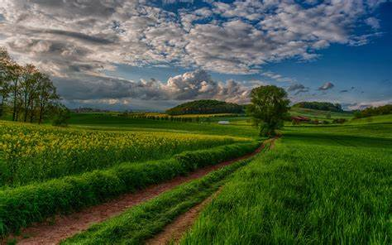 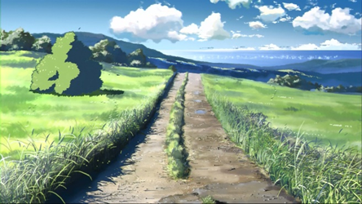

After import the content and style image, I load a pre-trained VGG-19 network, which is an award-wining convolutional neural network with 19 layers using for image classification for 1000 objects. We use its intermediate layers to get the content and style representation of the image. These intermediate layers are necessary to define the representation of content and style from the images. As for why do these intermediate outputs within VGG-19 network allow us to define style and content representations, when we put a raw image into the model, before it goes to output classification label, somewhere in between it serves as a complex feature extractor. Thus, we are able to describe the content and style of the input image by accessing the intermediate layers of the model.

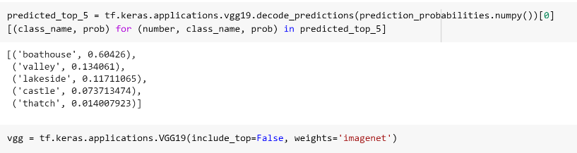 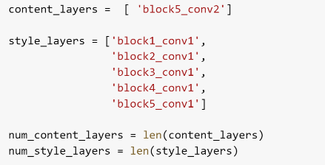

With content and style representations defined, we can now extract the values of the intermediate layers using keras functional API:

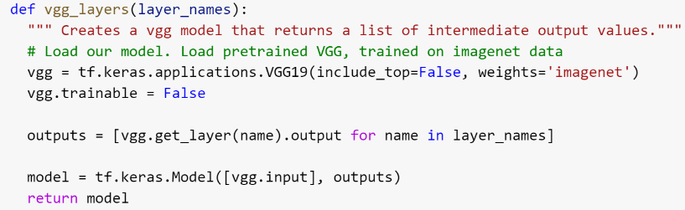 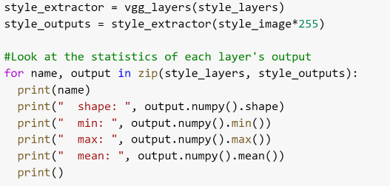

The values of the intermediate feature maps can be used to represent the content of an image and the means and correlations across the different feature maps describe the style of an image. We calculate the Gram matrix that includes this information for target layers using following function:

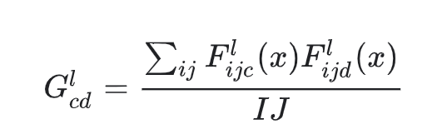

Then we build the models to extract the style and contents:

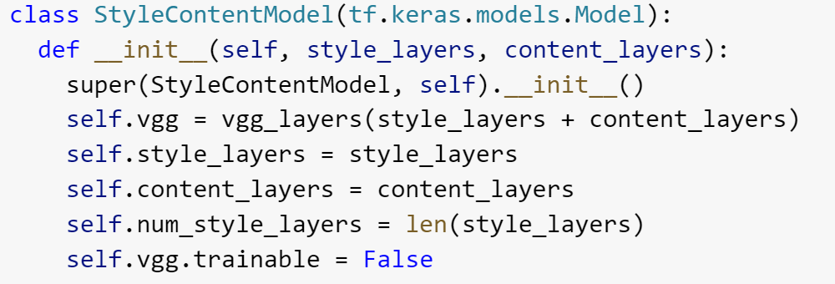 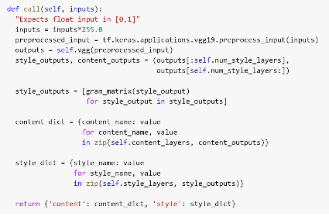

With this style and content extractor, we can finally perform gradient descent to visualize the image information that is encoded at different layers of the hierarchy, which is content representations. I did 2000 steps of style transfer training where it synthesizes a new image that simultaneously matches the content representation of the style representation. Here is the output image after this first run:

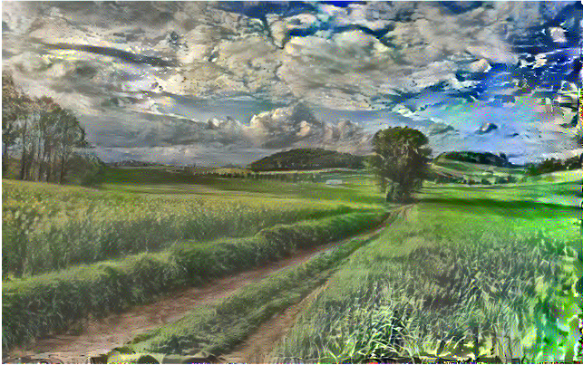

This initial result shows a noticeable style shift towards the anime style. However, I also notice there is a significant increase of artifacts, thus results in entire image looking not smooth and kind of dirty. I then perform optimization called total variation loss, which is the technique to decrease high frequency artifacts using an explicit regularization term on the high frequency components of the image. I increased the total variation loss weight and ran the training for another 2000 steps. This is the final output image after optimization:

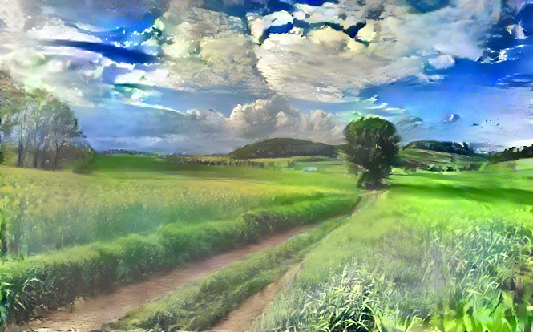

This shows significant improvement compares to the last image. Although it’s still not perfect I settled with this implementation and performed it with lots of different content and style images. I will show the result and analysis in the next part.

**Result**

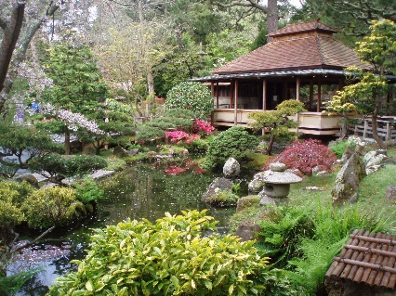 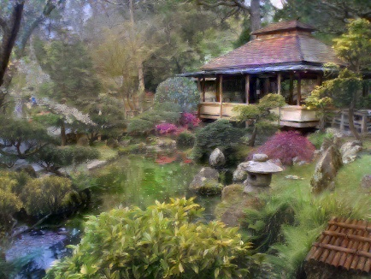 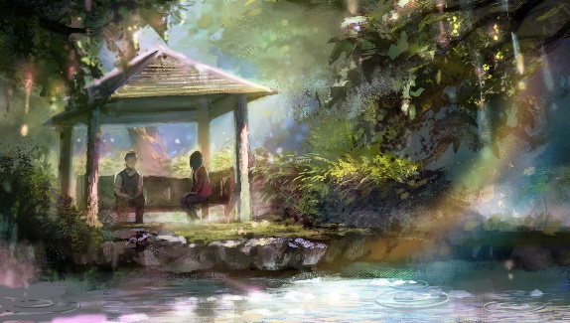

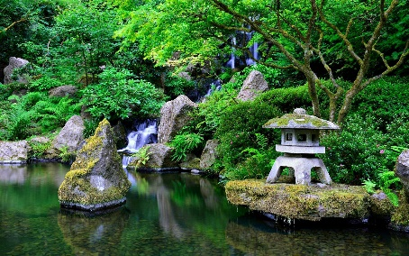 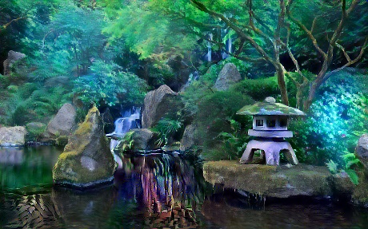 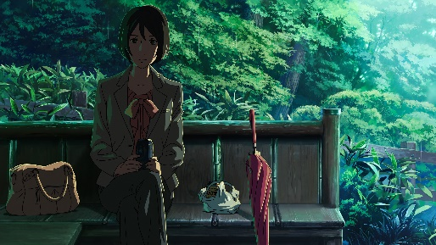

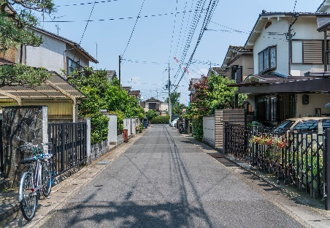 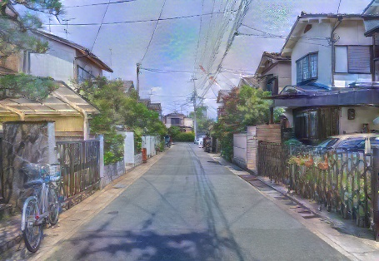 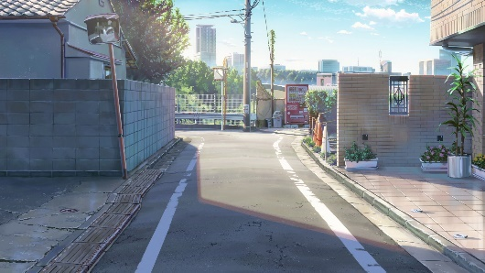

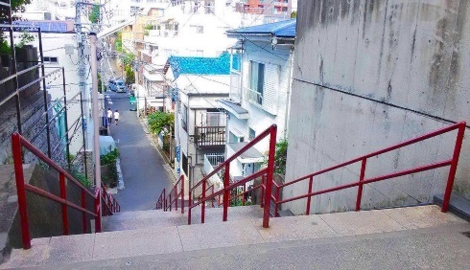 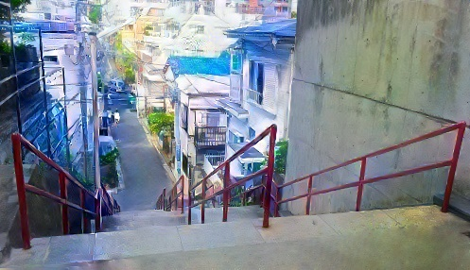 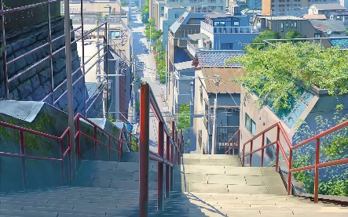

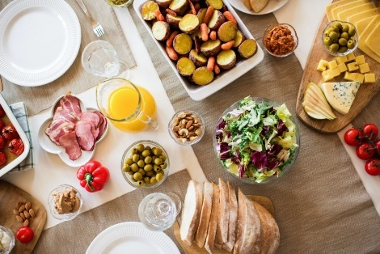 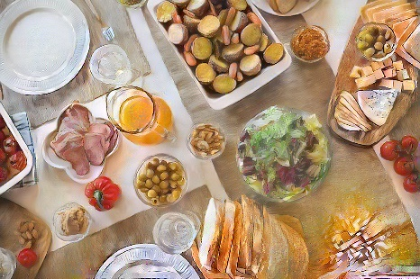 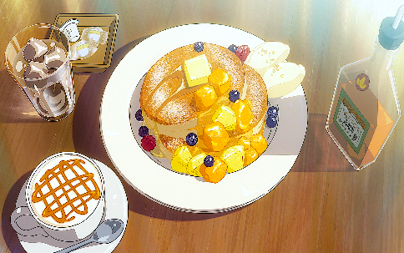

Input image Output image Style image

Above are some samples of the result. Although some of these output images still have some minor issues like add-on objects, artifacts, colors or blurred edges and objects, etc. Overall, they look pleasant and pretty close to the style of the style images. One thing I noticed is that while Shinkai’s style always has that very smooth yet detailed texture, the output images from NST tend to be smooth with less details, or detailed with less smoothness. It works very nice on natural scene content. The other image content seems to be ok as well although not as impressive as natural scene, with one exception of human content. Here are some completely unsatisfactory samples:

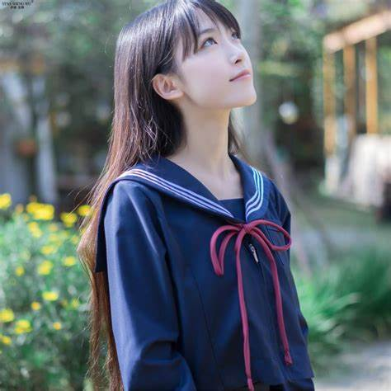 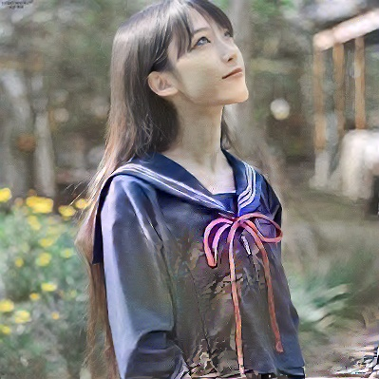 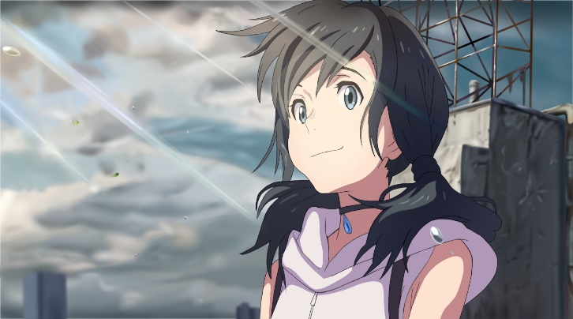

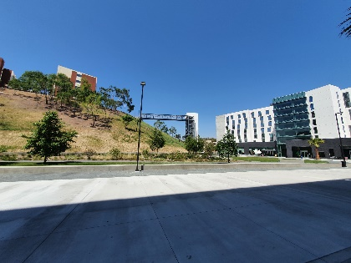 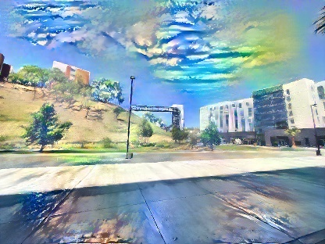 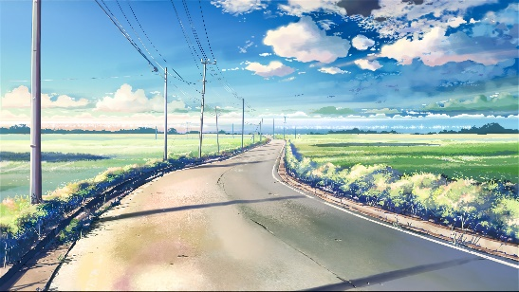

Input Image Output Image Style Image

These show the problems of the NST besides it can only take and train one image each time. It doesn’t work on human images, which is understandable since anime characters and real-life people are fundamentally different in style, even the most advanced AI can’t turn a real-life people image into a perfect 2D anime character image. The second image on the other hand show a significant disadvantage of the NST, which is the match between the content and style images. While there is always some trade-off between content and style matching, If the content image and style image’s content, color tone, composition are way too different, the result is most likely a failure.

**Style Image Dataset and Image Similarity Search**

My initial goal is to use arbitrary images for the style transfer. However, with the problem mentioned above, I definitely can’t throw an arbitrary image to it. Besides avoiding the human images, I also have to look up for the style images which match my content images every time. This is not acceptable. Thus, I came up with the idea to make a style image dataset, with enough images in it so it can find a style image to match the content image no matter what I throw to it. I collect over 300 images of Shinkai’s anime movies which contain lots of different content and color tones. After that, I tried out different methods including MSE (Mean Square Error), SSIM (Structure Similarity) and histogram to compare the image similarity to see which one provides best match to the input image. Histogram comparison gave the best result, probably because NST itself uses the histogram-based texture synthesis. Below are some the highest similarity results from histogram comparison:

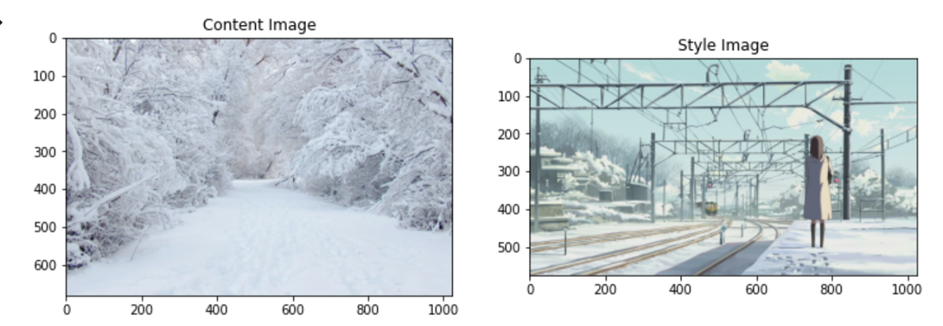

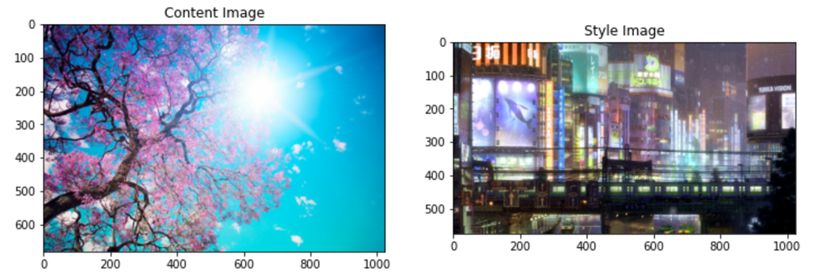

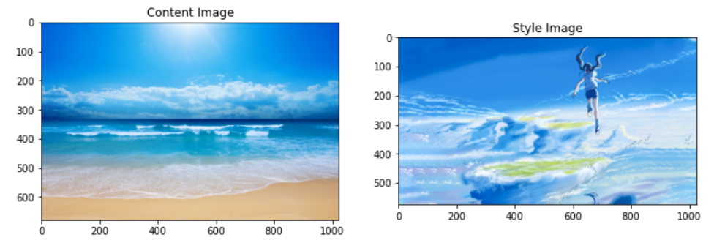

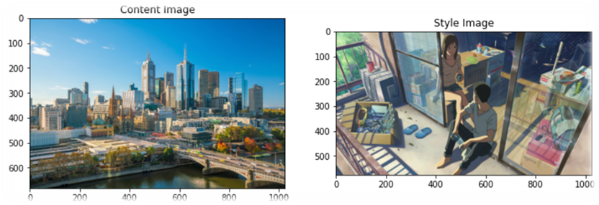

Input Image Highest Match Image

As shown above, it did a good job for most of the time, but it does return completely off-style images sometimes. I think it already reaches the limitation of simple and quick image comparison method at this point. For anything better, I would probably need to go for more complex and time-consuming methods like using the CNN again for the image similarity comparison.

**Related Work**

I found a similar project which used GAN method on the Github, which is called ‘AnimeGAN’, created by Tachibana Yoshino. (<https://tachibanayoshino.github.io/AnimeGANv2/>)

Here are some of the result sample images from his work:

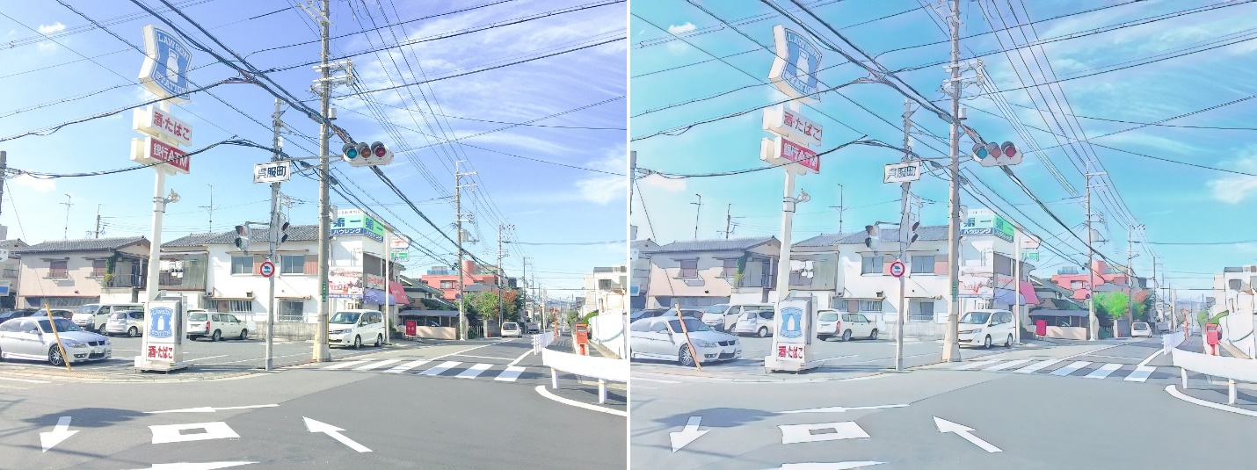

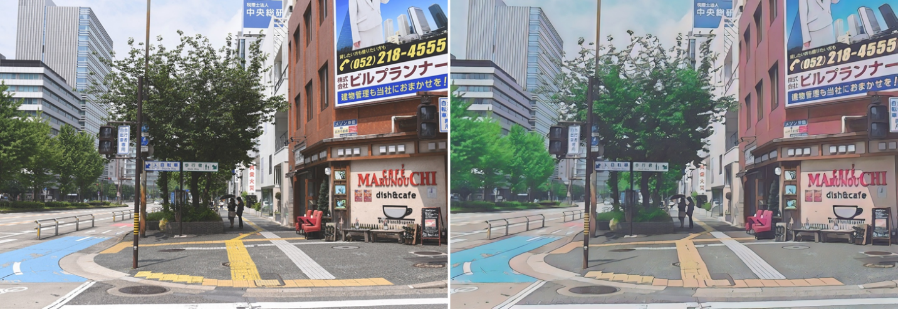

The result images show a clear step up from my work, especially in terms of smoothness and cleanness. This proves that GAN is indeed better than NST when it comes to create anime style image. The only issue with this method is that the style seems to be too subtle here.

**Conclusion**

Before I wrap up my conclusion, here is a Shinkai Style anime image I created using Photoshop under ten minutes and the one generated with NST over twenty minutes:

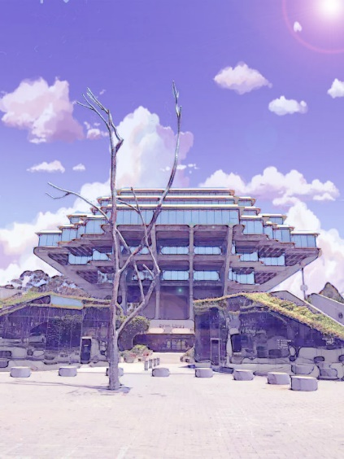 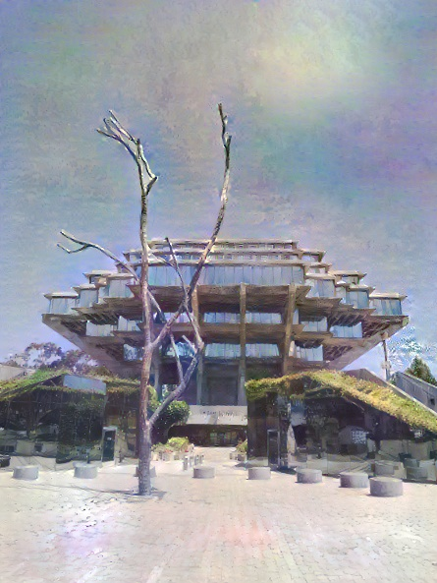 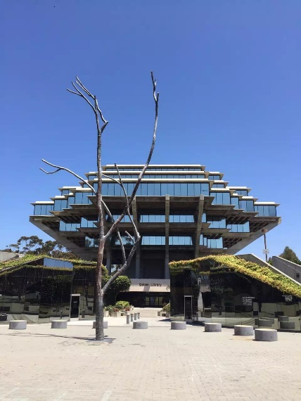

Photoshop NST Original

As you can see above while NST does achieve a pretty good result in transferring anime art style to real-life image, it still can’t compete with manual control computer software like Photoshop. Keep in mind that NST also spends way more time to generate the image. This is not only limits to NST but also the same case for GAN. Although GAN is a step above NST in terms of anime style image transformation, it still loses to Photoshop, and it spends even much more time than NST, although its multiple images and styles generation ability might make up for that. It turns out that AI still has a long way to go if it wants to compete with human in terms of creating anime style images. However, for those people who has no advanced photo editing skills, either NST or GAN can help them achieve a pretty decent result in transferring the anime art style to real-life images.

**Future Work**

Although I don’t think any AI can beat my Photoshop skill for now when it comes to anime style image transformation, I still want to try out GAN method by myself, that will be an instant upgrade from what I have implemented in this paper. Even for the same NST method, I do think it can be implemented in a better way. For example, I didn’t try pre-processing the input and style images, it might help a lot if some necessary operations are done to these images like contrast, smoothness, edges, etc. Also, I could have done the CNN image similarity search for better matching of content and style images. All of these can be implemented for my future work.